Figure 1. Modified WLNM for link prediction in food webs. a The observed directed food web, containing positive links, is partitioned into training and test sets. b Negative links are generated using ecological constraints to define the eligible negative pool, from which negative links are sampled and partitioned into training and test sets. c A directed enclosing substructure around the focal pair is extracted while preserving the direction of their interactions. d The initially coloured subgraph is then refined using Palette-WL and canonically relabelled, producing a consistent node ordering for subsequent matrix encoding. e The ordered substructure is converted into a fixed-length vector representation, with the entry marked by a question mark illustrating the focal-link position. The binary matrix and focal-node ordering are schematic. In the implementation, the focal interaction is removed from the binary subgraph used for relabelling; the weighted input is constructed separately, with the masking limitation described in Methods. f Encoded representation is used as input to a feed-forward neural network to estimate the score of the candidate interaction.

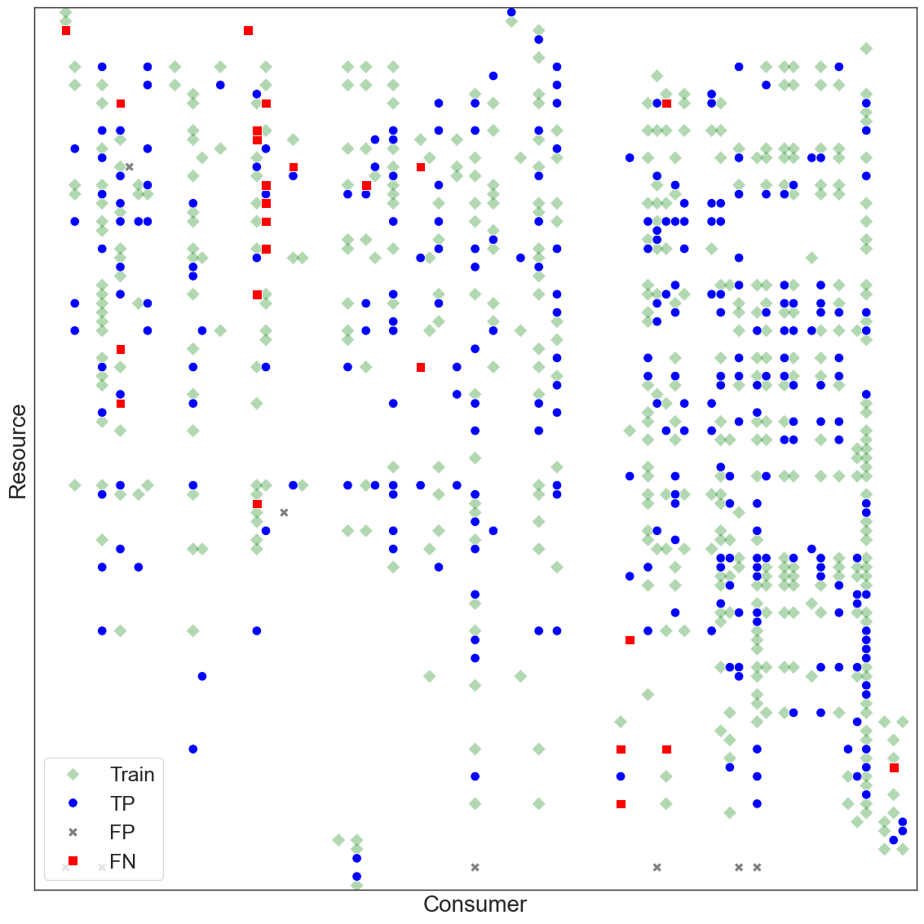

Figure 2. Directed food-web matrix of a food web with link prediction results. Species are ordered in ascending order of body mass (from top to bottom and from left to right). Trophic interactions are categorized into those used for training (green diamonds), correctly identified by the predictor (true positives, blue circles), predicted but absent in the empirical food web (false positives, grey crosses) and observed links that have not been generated (false negatives, red squares). To keep the visualisation simple, negative samples and true negatives are not explicitly shown here. Species names and their body mass can be found in Supplementary Table 1. The matrix shows the selected illustrative run at 60% training and a classification threshold of 0.5 (experiment 21), with 460 training positives, 284 true positives, 8 false positives and 24 false negatives. Selection minimised false negatives across 50 runs, with ties resolved by fewer false positives, higher F1 and higher MCC.

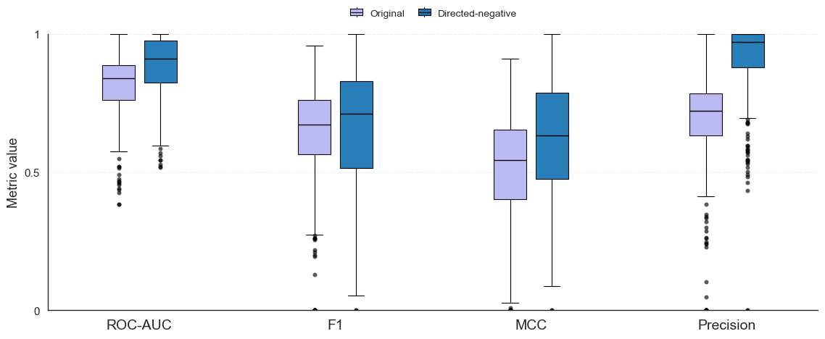

Figure 3. Accuracy of the prediction of trophic links. Performance is reported for ROC-AUC, F1, MCC and Precision with a training ratio of 90% for the original WLNM (light colour) and the extended WLNM for ecological networks (dark colour). Boxplots show the median (centre lines), and preserved outliers (circles), with edges and whiskers representing the 25% and 75% quartiles, and the most extreme observations within 1.5×IQR of the quartiles, respectively, with n = 290 for each metric. Each food web contributes one mean per metric after Tukey’s 1.5×IQR filtering, requiring at least 25 of 50 runs; classification used a threshold of 0.5. The seven-metric comparison is shown in Supplementary Figure 7.

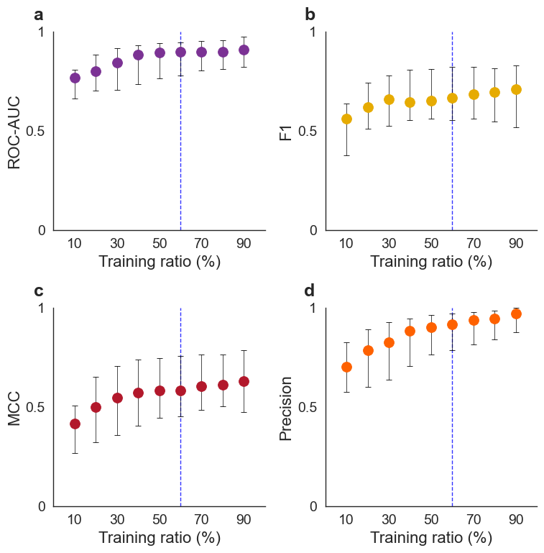
Figure 4. The effect of training ratio on model performance. a–d Predictive performance across training ratios from 10% to 90% with respect to ROC-AUC (a), F1 (b), MCC (c) and Precision (d), respectively. Points show medians and error bars span the 25th–75th percentiles across food-web means after Tukey filtering. The vertical dashed line marks the 60% training ratio. Classification used a threshold of 0.5, and each food-web mean required at least 25 of 50 runs retained after metric-specific Tukey filtering.

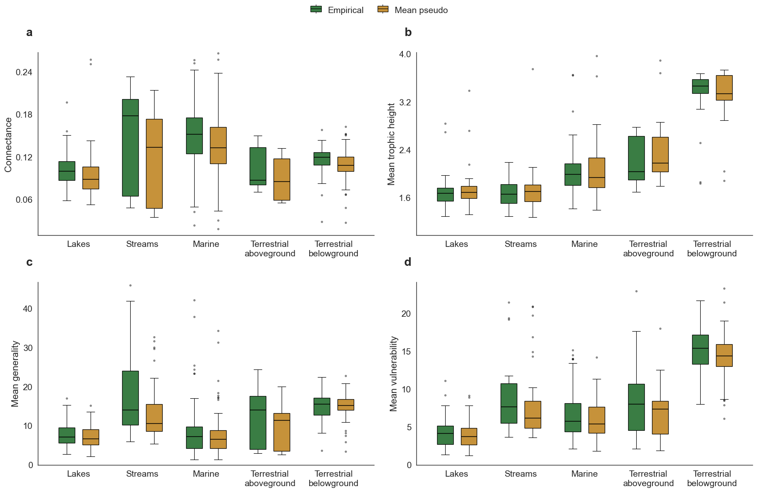

Figure 5. Comparison on food web properties between empirical and pseudo webs. a–d Connectance (a), average trophic height (b), mean generality (c), and mean vulnerability (d), between empirical (dark colour) and pseudo (light colour) food webs across ecosystem types. Pseudo food webs were reconstructed from models trained using a 60% split of observed trophic links. For each food web, pseudo-web values represent the mean across retained pseudo-web realisations after removing pseudo-run outliers using Tukey’s 1.5×IQR rule within each food web and metric. Boxplots show the median (centre lines), and outliers (circles), with edges and whiskers representing the 25% and 75% quartiles, and the most extreme observations within 1.5×IQR of the quartiles, respectively, with n = 55, 28, 134, 21 and 52 paired food webs for lakes, streams, marine and terrestrial above- and below-ground, respectively, for connectance, generality and vulnerability; trophic-height sample sizes are 55, 28, 133, 21 and 51. Each pseudo mean requires at least 25 of 50 retained runs, and classification uses a threshold of 0.5.

Utilising substructural patterns in food webs to infer trophic links

Jorge Eduardo Castro Cruces ¹, Lachlan G. Burton¹, Athen Ma^{1*}

Supplementary Figures and Tables

Supplementary Table 1. Species for a terrestrial aboveground food web named Grand Caricaie marsh dominated by Cladietum marisci, not mown ClControl2. Species are organised in ascending order of body mass (in milligrams).

ID | Species name | Mass (mg)
1 | Sminthuridae | 0.0295
2 | Poduromorpha | 0.0295
3 | Acari phyto | 0.0345
4 | Acari pred | 0.0345
5 | Araneidae | 0.0345
6 | Hahnia sp | 0.0345
7 | Cecidomyiidae | 0.0532
8 | Theridion sp | 0.0964
9 | Ootetrastichus sp | 0.2126
10 | Stilicus rufipes | 0.2454
11 | Cicadoidea | 0.2590
12 | Tetragnatha sp | 0.3455
13 | Mangora acalypha | 0.3455
14 | Delphacidae | 0.3787
15 | Cercyon sternalis | 0.4050
16 | Hybotidae | 0.4571
17 | Chironomidae | 0.4715
18 | Hypostenus latifrons | 0.4909
19 | Bidessus unistriatus | 0.4909
20 | Sciaridae | 0.5316
21 | Ephydridae | 0.5316
22 | Jassidae | 0.5424
23 | Linyphiidae | 0.5666
24 | Phlaeothripidae | 0.5898
25 | Theridiidae | 0.6909
26 | Thanatus sp | 0.6909
27 | Typhlocybinae | 0.7281
28 | Psychodidae | 0.7442
29 | Gnathonarium dentatum | 0.7496
30 | Bathyphantes setiger | 0.7773
31 | Limoniidae | 0.7973
32 | Homoptera | 0.8503
33 | Chloropidae | 0.8531
34 | Culex sp | 0.9036
35 | Clubiona sp | 0.9604
36 | Ceratopogonidae | 1.0061
37 | Philodromidae | 1.2056
38 | Antistea elegans | 1.2449
39 | Herina parva | 1.3289
40 | Thomisidae | 1.3818
41 | Muscidae flor | 1.4565
42 | Muscidae copro | 1.4565
43 | Pardosa sp | 1.4924
44 | Polyhydrus lineatus | 1.9634
45 | Clubiona juvenis | 2.0624
46 | Pteromicra leucopeza | 2.1262
47 | Pirata sp | 2.1937
48 | Ichneumonidae | 2.2591
49 | Paederus riparius | 2.4543
50 | Trachelipus rathkei | 2.6543
51 | Sitticus caricis | 3.3579
52 | Cloeon simile | 3.5391
53 | Hebrus pusillus | 3.8115
54 | Chartoscirta cincta | 3.8848
55 | Jassinae | 4.5201
56 | Staphylinidae | 4.7074
57 | Dryops auriculatus | 5.1540
58 | Salticidae | 5.1621
59 | Pachybrachius sp | 5.3508
60 | Asellus aquaticus | 5.6330
61 | Sepedon spinipes | 7.1759
62 | Lepidoptera | 7.3485
63 | Caenis sp | 8.2578
64 | Anthocomus coccineus | 8.8845
65 | Odacantha melanura | 9.4490
66 | Gerris sp | 10.3223
67 | Sepedon sphegea | 10.631
68 | Pisaura mirabilis | 10.7092
69 | Araneae | 10.8819
70 | Pirata piraticus | 11.2274
71 | Larinioides sp | 11.2619
72 | Lycosidae | 12.8510
73 | Calliphoridae | 13.6875
74 | Stratiomyidae | 15.0961
75 | Arctosa sp | 15.8911
76 | Tibellus sp | 18.9367
77 | Larinioides cornutus | 36.9640
78 | Paravespula vulgaris | 40.6637
79 | Oligochaeta | 89.0617
80 | Dolomedes sp | 106.7465
81 | Sympetrum sanguineum | 146.2814
82 | Anisus leucostoma | 162.5949
83 | Sympetrum vulgatum | 239.4768
84 | Sympetrum sp | 244.7854
85 | Oxyloma elegans | 266.9007
86 | Colymbetes fusca | 279.7892
87 | Somatochlora sp | 315.5667
88 | Trichia sericea | 361.4578
89 | Sympetrum striolatum | 516.1137
90 | Glossiphonia heteroclita | 519.6601
91 | Rana sp | 2000
92 | Emberiza schoeniclus | 20000
93 | Microtus agrestis | 35000
94 | Natrix natrix | 100000
95 | Falco subbuteo | 210000
96 | Vulpes vulpes | 5000000
97 | Capreolus capreolus | 20000000

Supplementary Figure 1. Directional information preserves trophic roles that are lost in undirected graphs. a A motif formed by one resource (green) and two consumers (blue) and the corresponding directed food-web matrix. b A motif formed by two resources and one consumer and the corresponding directed food-web matrix. c-d Undirected connection matrices for (a) and (b) respectively. Ignoring directionality makes the two motifs isomorphic, although their displayed adjacency matrices use different node orders; undirected links do not distinguish a resource from a consumer.

Supplementary Figure 2. Ecologically meaningful negative links for model training. a An example of a food web with basal (green), intermediate (blue), and top consumer species (red). Interactions are categorized into positive links which are observed trophic links (solid lines), and negative links which are unobserved links that are also ecologically implausible (dashed lines), such as between two basal species or between two top consumers. b Directed food-web matrix of (a) with positive links (dark circles) and negative links (grey circles).

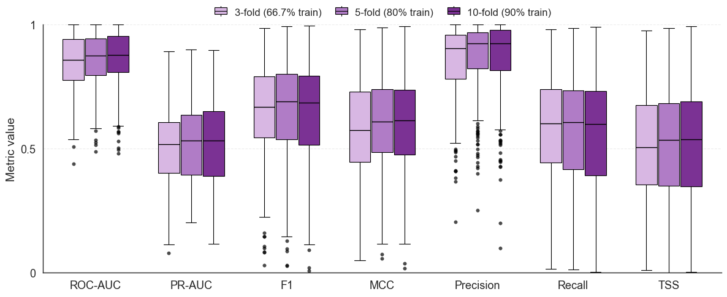

Supplementary Figure 3. K-fold validation on the modified WLNM for link prediction in food webs. Performance scores under 3-, 5-, and 10-fold cross-validation, corresponding to approximately ~67%, 80% and 90% of data used for training, respectively. Performance is reported for ROC-AUC, PR-AUC, F1, MCC, Precision, Recall and TSS. Boxplots show the median (centre lines), and outliers (circles), with edges and whiskers representing the 25% and 75% quartiles, and the most extreme observations within 1.5×IQR of the quartiles, respectively, with n = 290 for each metric and 20 repetitions of model fitting and negative sampling on fixed folds per food web. Fold-level values were averaged within each repetition before metric-specific Tukey filtering, requiring at least 10 of 20 repetitions. Classification used a threshold of 0.5.

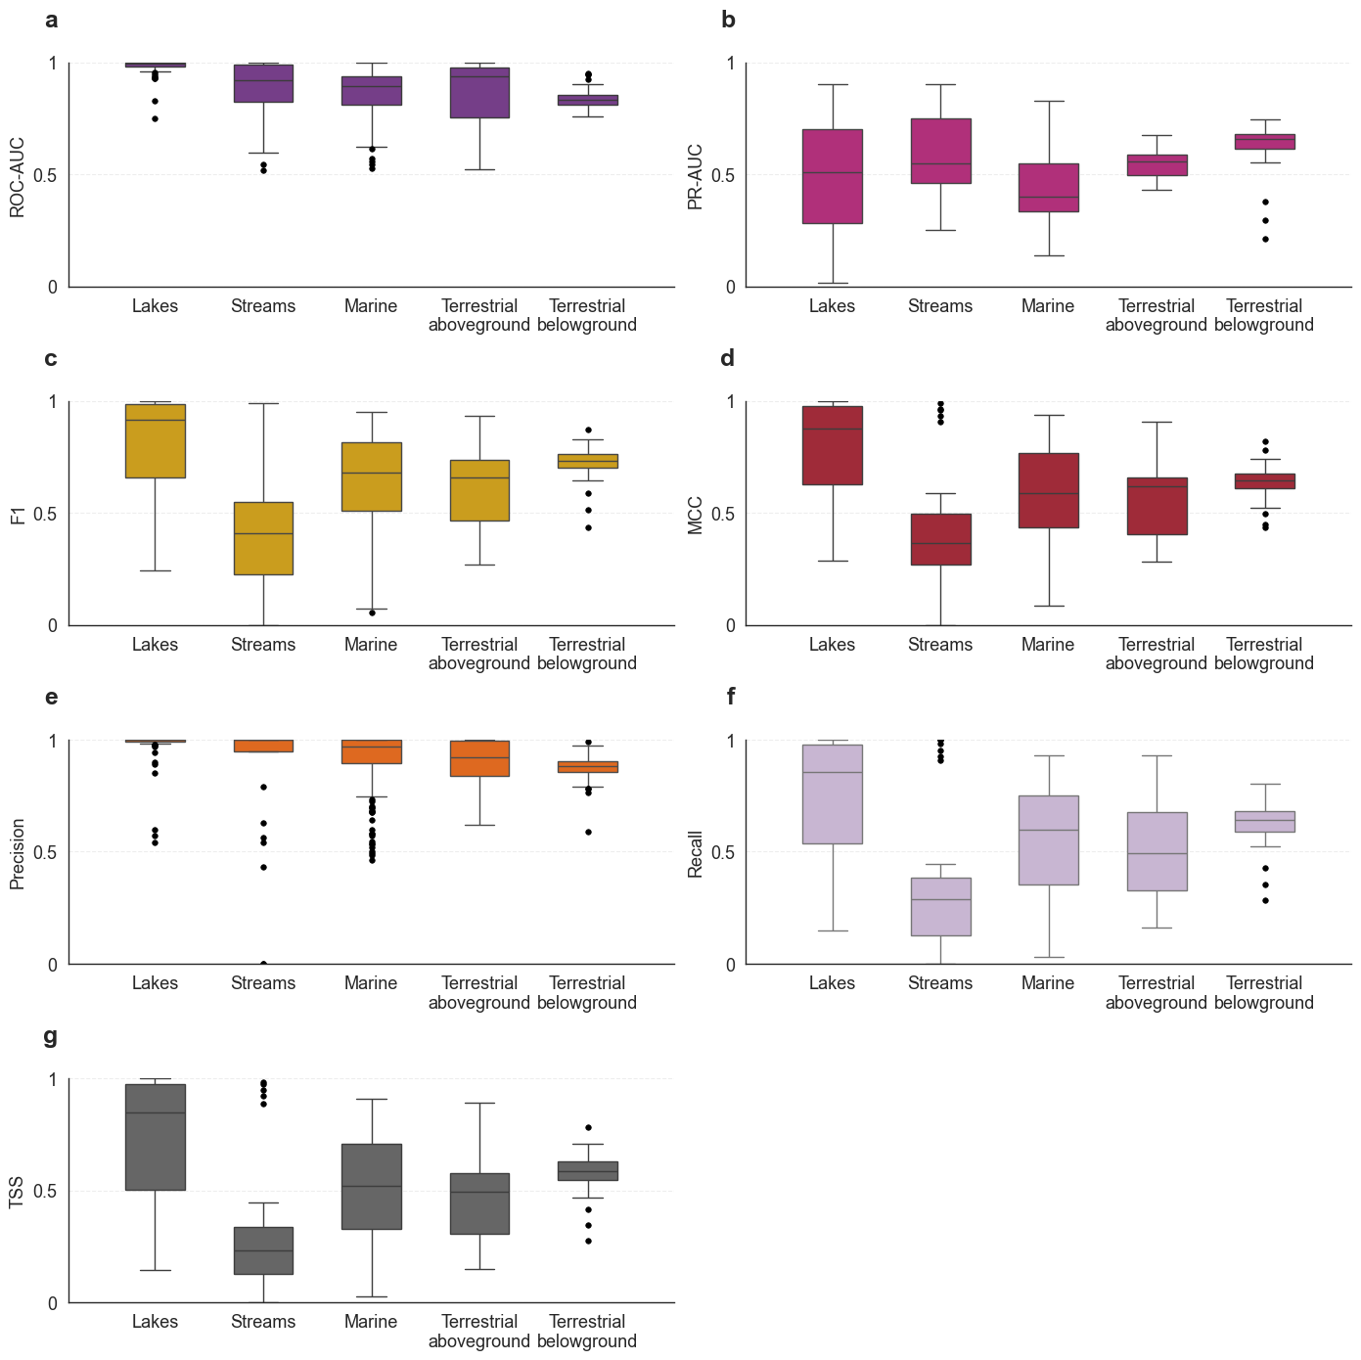

Supplementary Figure 4. Comparison on model performance across ecosystem types. a–g Performance is reported for ROC-AUC (a), PR-AUC (b), F1 (c), MCC (d), Precision (e), Recall (f) and TSS (g) for lakes, streams, marine, terrestrial above- and below-ground. Boxplots show the median (centre lines), and outliers (circles), with edges and whiskers representing the 25% and 75% quartiles, and the most extreme observations within 1.5×IQR of the quartiles, respectively, with n = 55, 28, 134, 21 and 52 for lakes, streams, marine and terrestrial above- and below-ground respectively (each food web contributes one mean value across at least 25 retained runs from 50 repetitions after metric-specific Tukey filtering, at 90% training and classification threshold 0.5).

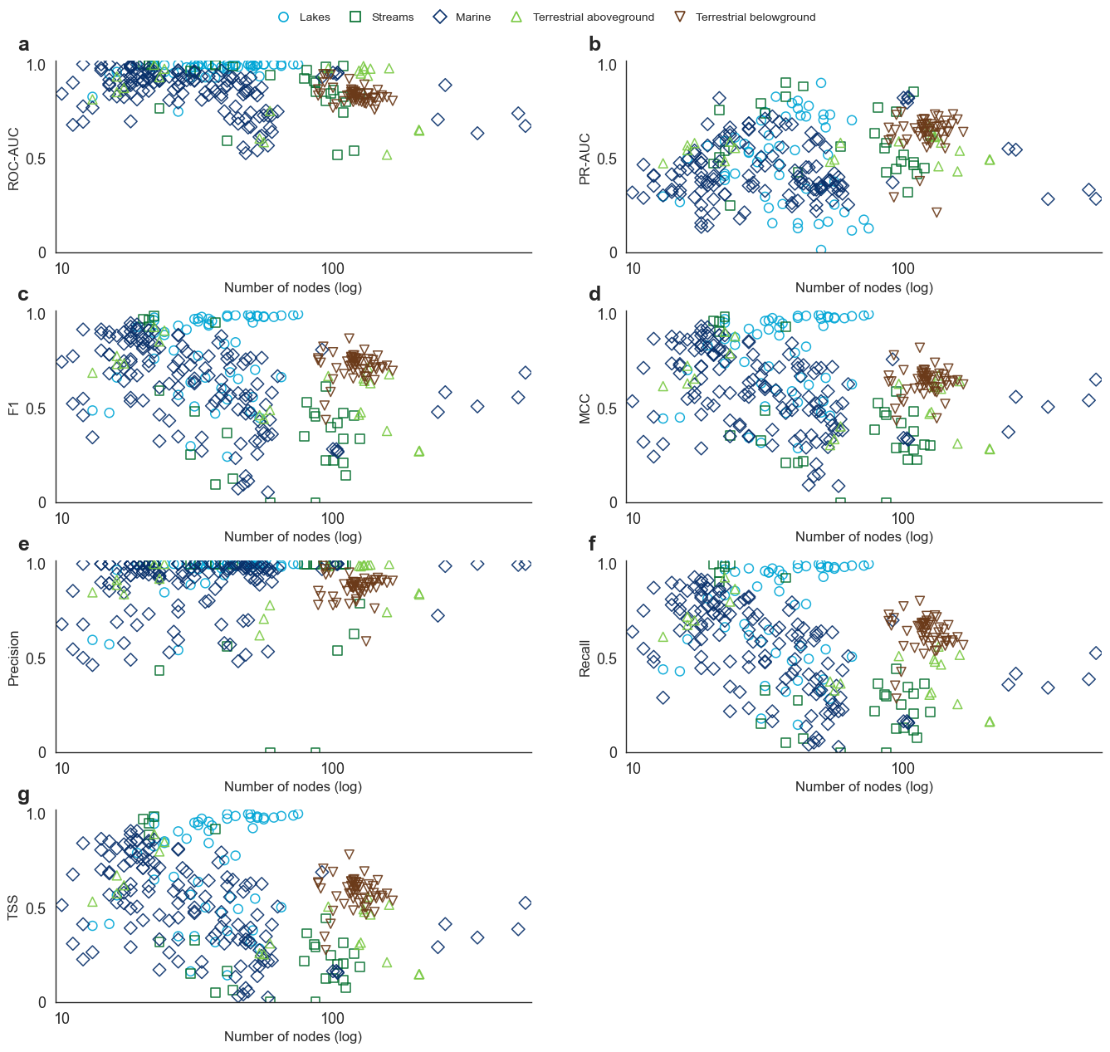

Supplementary Fig. 5. Predictive performance across empirical food-web size. a–g Performance is reported for ROC-AUC (a), PR-AUC (b), F1 (c), MCC (d), Precision (e), Recall (f) and TSS (g) against the number of nodes for all food webs in lakes (circles), streams (squares), marine (diamonds), terrestrial above- (triangles) and below-ground (inverted triangles). The training ratio was 90%, and for each metric, the mean result over at least 25 retained runs from 50 repetitions, after metric-specific Tukey filtering at classification threshold 0.5, is reported for each web. Food-web size explained little variation in predictive performance, despite several statistically significant but weak associations, including ROC-AUC (F_{1,288} = 36.8364, P < 0.0001, r² = 0.1134; y = 0.9180 - 0.0006x), PR-AUC (F_{1,288} = 8.6125, P = 0.0036, r² = 0.0290; y = 0.4719 + 0.0005x), F1 (F_{1,288} = 9.2940, P = 0.0025, r² = 0.0313; y = 0.7072 - 0.0007x), MCC (F_{1,288} = 10.2169, P = 0.0015, r² = 0.0343; y = 0.6630 - 0.0007x), Precision (F_{1,288} = 0.0188, P = 0.8912, r² = 0.0001; y = 0.9028 + 0.000020x), Recall (F_{1,288} = 17.9205, P < 0.0001, r² = 0.0586; y = 0.6478 - 0.0010x) and TSS (F_{1,288} = 14.0341, P = 0.0002, r² = 0.0465; y = 0.6017 - 0.0009x). Regressions were fitted using untransformed node counts. Regression lines are not shown here as the x-axes are in log scale.

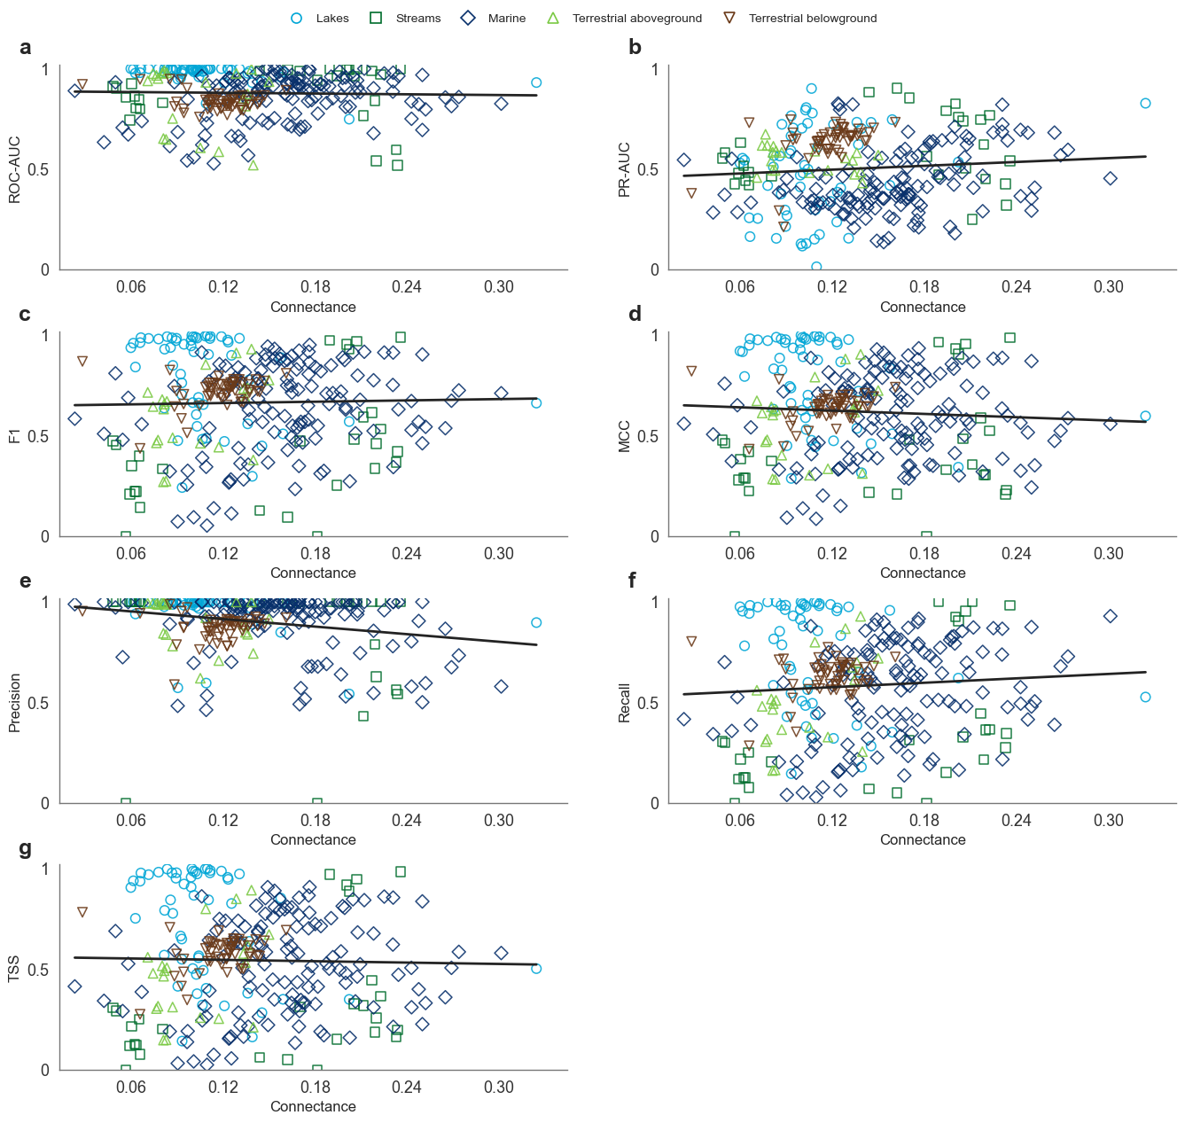

Supplementary Figure 6. Predictive performance across empirical food-web connectance. a–g Performance is reported for ROC-AUC (a), PR-AUC (b), F1 (c), MCC (d), Precision (e), Recall (f) and TSS (g) against connectance for all food webs in lakes (circles), streams (squares), marine (diamonds), terrestrial above- (triangles) and below-ground (inverted triangles). The training ratio was 90%, and for each metric, the mean result over at least 25 retained runs from 50 repetitions, after metric-specific Tukey filtering at classification threshold 0.5, is reported for each web. Connectance was found to have no significant effect on ROC-AUC (F_{1,288} = 0.2306, P = 0.6314, r² = 0.0008; y = 0.8873 - 0.0617x), PR-AUC (F_{1,288} = 2.4072, P = 0.1219, r² = 0.0083; y = 0.4597 + 0.3176x), F1 (F_{1,288} = 0.1726, P = 0.6781, r² = 0.0006; y = 0.6502 + 0.1091x) and MCC (F_{1,288} = 1.1600, P = 0.2824, r² = 0.0040; y = 0.6582 - 0.2723x). Connectance showed a weak association with Precision (F_{1,288} = 13.8700, P = 0.0002, r² = 0.0459; y = 0.9908 - 0.6286x), while no significant effects were found for Recall (F_{1,288} = 1.5282, P = 0.2174, r² = 0.0053; y = 0.5326 + 0.3649x) and TSS (F_{1,288} = 0.1477, P = 0.7010, r² = 0.0005; y = 0.5600 - 0.1129x).

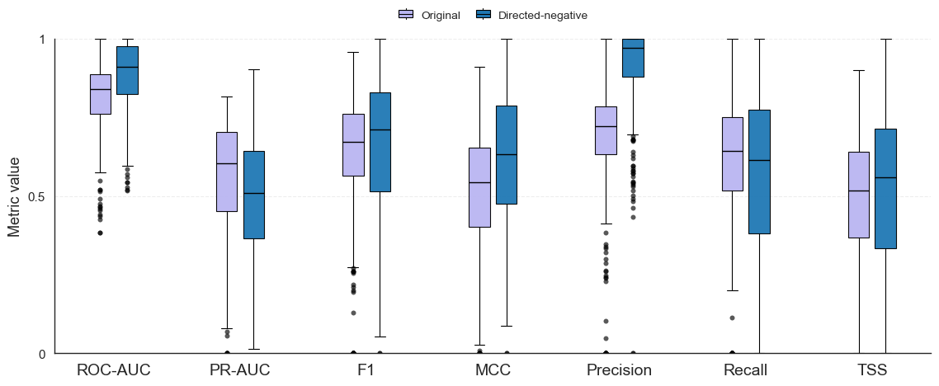

Supplementary Figure 7. Accuracy of the prediction of trophic links. Performance is reported for ROC-AUC, PR-AUC, F1, MCC, Precision, Recall and TSS with a training ratio of 90% for the original WLNM (light colour) and the extended WLNM for ecological networks (dark colour). Boxplots show the median (centre lines), and outliers (circles), with edges and whiskers representing the 25% and 75% quartiles, and the most extreme observations within 1.5×IQR of the quartiles, respectively, with n = 290 for each metric. Each food web contributes one mean per metric after Tukey’s 1.5×IQR filtering, requiring at least 25 of 50 runs; classification used a threshold of 0.5.

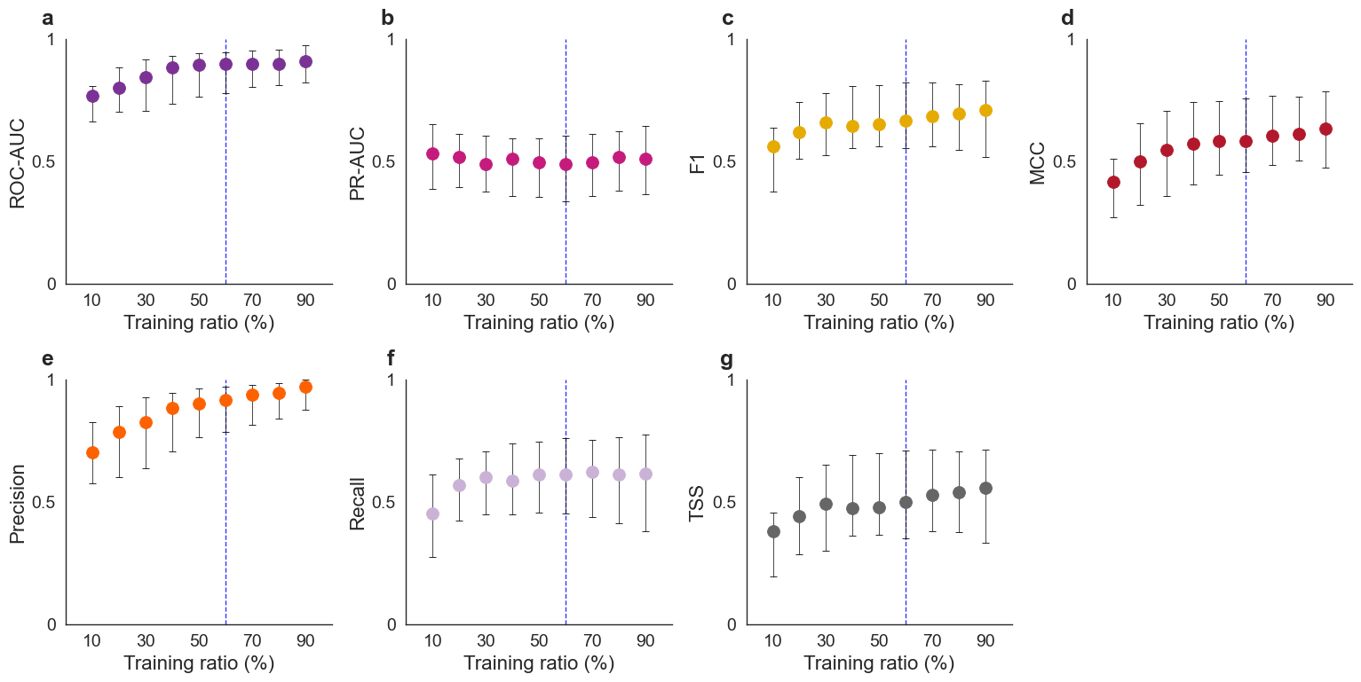
Supplementary Figure 8. The effect of training ratio on model performance. a–g Predictive performance across training ratios from 10% to 90% with respect to ROC-AUC (a), PR-AUC (b), F1 (c), MCC (d), Precision (e), Recall (f) and TSS (g), respectively. Points show medians and error bars span the 25th–75th percentiles across food-web means after Tukey filtering. The vertical dashed line marks the 60% training ratio. Classification used a threshold of 0.5, and each food-web mean required at least 25 of 50 runs retained after metric-specific Tukey filtering.

